**Partial Derivatives**

Table of Contents

First Order Partial Derivates 2

Higher Order Partial Derivatives 4

## First Order Partial Derivates

The **rate of change** of a function with respect to one of several independent variables is called the **partial derivative**.

If , then the **first partial derivatives** of with respect to and are the functions and .

To find , we consider a constant value of and **differentiate** with respect to and vice versa.

The **value** of the partial derivate at the point is denoted as .

Geometrically, if , then is the curve **intersecting** the surface and the plane .

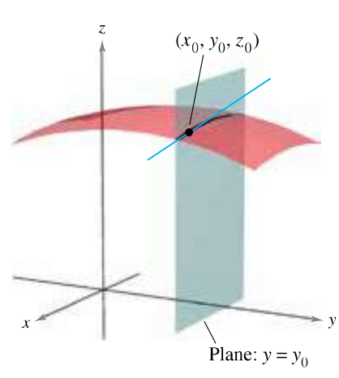

Thus, is the intersecting line. The exact value we get represents the **slope** of the surface along the -axis at that point, like how represents the slope of the curve at .

We can extend the concept into the fourth dimension, where , and even more. All we need to do to find the partial derivative with respect to a specific variable is set values for the other variables and then differentiate with respect to that variable.

## Higher Order Partial Derivatives

The function has the following **second partial derivatives**:

The last two are called **mixed partial derivatives**.